Guidelines to EVA Platform – User
This guide will help you go through the EVA platform to test and develop your skills to be an entrepreneur and start your own business.
About the platform:
The EVA platform is a tool for potential entrepreneurs with a migrant background. The platform will look at your existing skills and mindset towards becoming an entrepreneur and guide you on areas where you might need to learn more.
The platform is not a full training in starting a business – but it can help you decide if it is the right choice for you and prepare you for what you need to know.
How to use the platform:
You do not need a login. You have to finish the sections that have questions and answers in one session (within about 30 minutes), because the system does not save your results for later.
You should use Google Chrome as browser, since the 3D environments in the last part of the platform works best with Google Chrome.
You can go to the 3 sections of the platform through the EVA website (www.eva-project.eu). On the front page of this website there is a menu at the top, where you can choose your country. The page you then go to is in the national language. On this page you will find links to the 3 sections.
As mentioned, the platform does not remember your answers, so finish the test you are doing before you return to the website and go to another section.
The platform is translated into the national languages of the partners (Danish, German, Italian, Cypriot Greek, Maltese and English (Malta)). You may find that some of the menu buttons are in another language – if this happens there is a link on your country’s page on the EVA website, to a site, where you can choose your country/language as shown in the picture below.

What is on the platform:
The platform is divided into 3 sections: Discover, Develop and Test (your enterprise skills).
Discover your enterprise skills: This section looks at the knowledge and experience you already have. Based on your given answers you will get feedback in different areas. The feedback will tell you which competencies and skills you will need to work on. You will also get suggestions on which units in the training materials you should focus on.
The questions will take approximately 20-30 minutes depending on how well you read the language. As previously mentioned the test has to be completed in one session, because the answers are not saved.
At the end of the questions, you will get a summary with your feedback. You can download the summary as a pdf or send it to an email address that you enter. Choose one of these options to save the feedback for later use – the feedback will not be saved in any other way in the system!!!
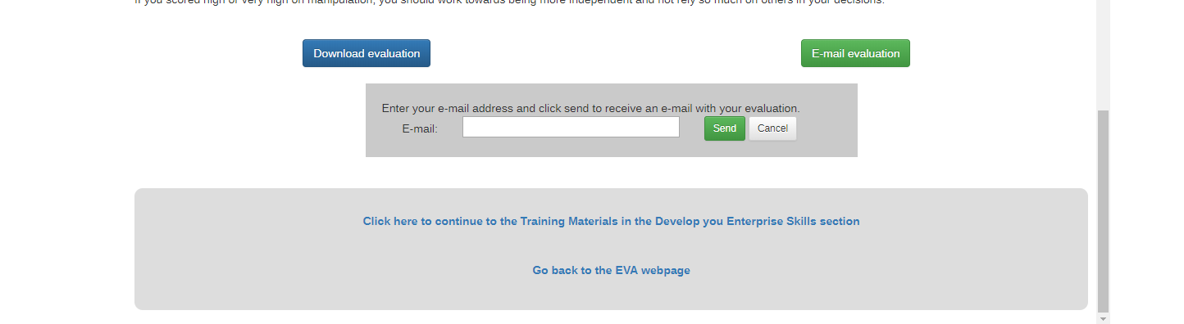
At the bottom of the page it is possible to continue directly to the Develop you enterprise skills with the training materials, or you can return to the EVA website and decide what to do next from there.
Develop your enterprise skills: In this section of the platform you will find links to information, guides and knowledge on entrepreneurship in your host country. The materials are split into 5 units with relevant topics:
1. Business Creation
2. Starting Your Business
3. Access to Finance
4. Sales & Marketing
5. Culture, Language, Communication and Networking.
From the summary you got in the first section, you might already know which units you need to focus on. All units are relevant for new entrepreneurs and the topics will all be part of the Enterprise Simulator and tests in the third section – so you might want to look at them all.
To navigate through the training material units use the ‘Course’ menu point at the top – this gives access to all 5 units.
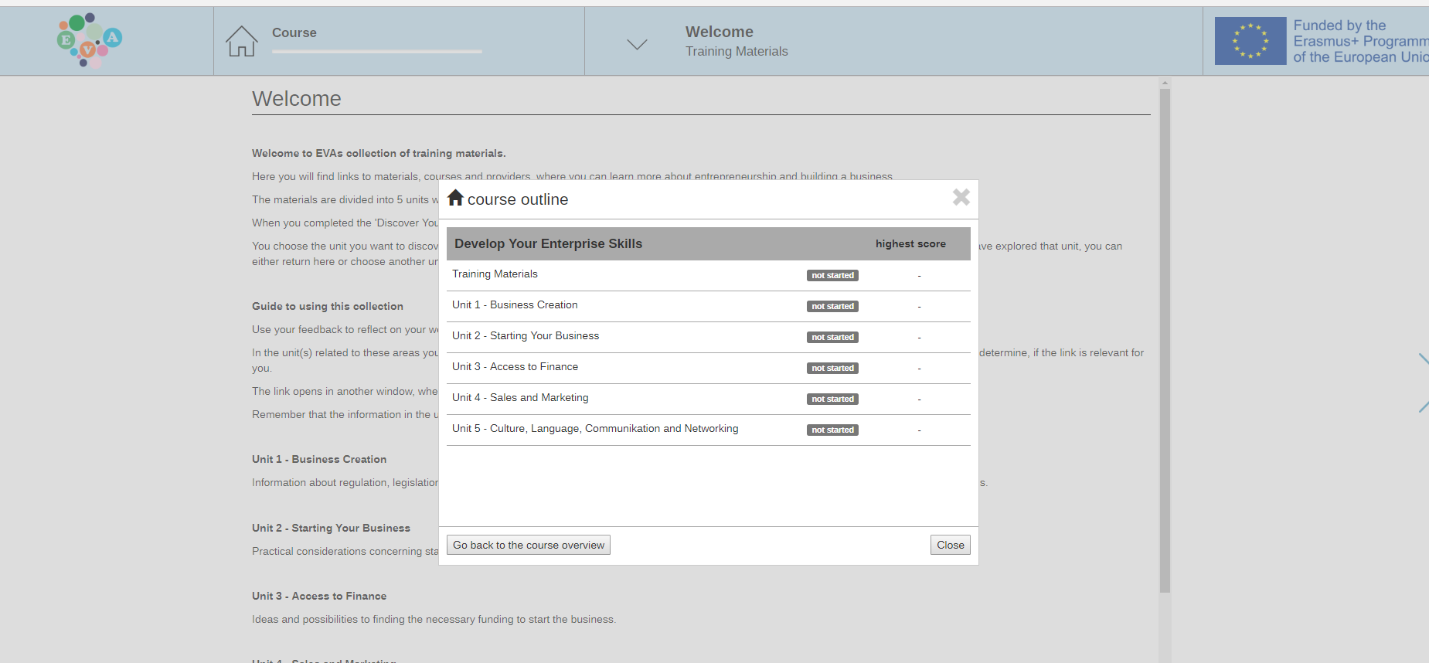
This is how the page will look after clicking the ‘Course’ menu – You can choose which of the units to go to in the list.
The menu point to the right of the ‘Course’ menu point can be used to navigate inside each unit between the different sub-units. You can also use the arrow on the right side of the screen, to go through all the sub-units one by one.
When you click on one of the links to the suggested training material, the page will open in a new tab/window, which will allow you to return to where you were in the platform when finished with exploring the page.
Test your enterprise skills: The final part of the platform consists of two related elements; a 3D environment with 5 typical situations for new entrepreneurs, plus 5 individual tests, one related to each situation.
When you enter the Enterprise Simulator you will land in a hall with 5 doors – each coloured door leads to a scenario. Each room in the simulator has a number of clickable elements (shown as grey circles), so when you move around in the scenario, you will meet these elements. When you click on one, a text will appear with a dilemma, situation, point of reflection, etc., where you have to reflect on what you would do.
To exit the room, you have to find the door/entrance in each scenario and click the circle there - this takes you back to the hall with the doors.
We recommend that you explore one scenario at a time, and after each scenario take the test related to the scenario. You will find a link to the test next to the image of the simulator, where each topic is listed with a link to take the test.
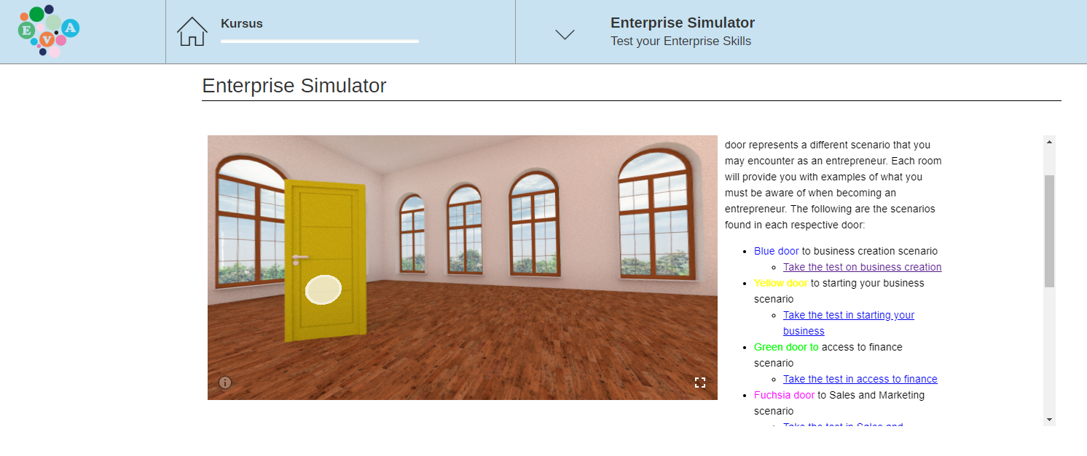You do not have to complete all tests in one go; once you have taken a test (and passed), you will get the validation of that test with a digital badge. You can explore the simulator over a longer period of time. Each test should take a maximum of 10 minutes to complete. Each test needs to be completed in one session, since the answers are not saved.
When you pass a test (you have to answer more than 75 % of the questions correct), you will get a digital badge. To store the badge you have to create your individual badge wallet (online and/or as a mobile app) if you do not already have one. To register you need to create an account with an email address and a password of your choice.
After registration, you can claim the badge and it will be saved as a digital diploma/certification, explaining what you have learned to earn the badge. You can get the badge by scanning the QR-code on the screen or enter the code that is shown (claim code – either in the app or on the website). Each code can only be used by one person.
Read more about the badge technology through: https://www.badgecraft.eu/
You will get one badge after each test, and when you have completed all 5 tests, you will get the overall EVA badge, certifying that you have gone through the platform and achieved the expected learning outcomes.

